Cointegration and ECM: GBPUSD and EURGBP
Method 27 / Engle-Granger on log closes / one-lag ECM / Alpari D1 full available history

Study setup
Logical pair: PX=GBPUSD , PY=EURGBP
Broker symbols: GBPUSD_i , EURGBP_i
Snapshot: 2026-11-03_majors_alpari_D1
Timeframe: D1
Matched window: 1999-01-06 to 2026-11-02 (UTC bar dates)
Matched level count n: 7199
Dropped unfinished last bar dated 2026-11-03 UTC after a tick-volume check against the prior complete day.
ECM lags of deltas: 1
Complete matched rows (Excel): GBPUSD-EURGBP_Coint_D1.xlsx
Complete matched rows (HTML table): GBPUSD-EURGBP_Coint_D1_data.html

Method carried forward
Engle-Granger cointegration works on log price levels, not returns. For each unordered pair, PX is the left leg and PY the right leg. Step one: OLS ln(PY) = alpha + beta * ln(PX) + e. Step two: statsmodels Engle-Granger coint test on (ln(PY), ln(PX)). Error-correction: delta ln(PY)_t = c + kappa * e_{t-1} + lagged delta ln(PY) and delta ln(PX) (one lag each) + u_t. Headline is the Engle-Granger p-value (lower = stronger evidence of a stationary spread) with kappa and beta reported alongside. Same-sample Pearson r of log returns is a side check only. beta is not an automatic lot-size hedge. This is not a trading signal.

Results (headline)
alpha: -0.046926
beta: -0.494893
Engle-Granger t: -1.712852
Engle-Granger p: 0.671008
5% critical value: -3.336979
ECM kappa: -0.000812
kappa t-stat: -1.5231
ECM R^2: 0.002255
spread std: 0.107641
Pearson r (returns): -0.397845

Conclusion
Engle-Granger for PY=EURGBP on PX=GBPUSD: beta=-0.4949, alpha=-0.0469, coint_t=-1.7129, p=0.6710 (5% crit=-3.3370). ECM kappa=-0.0008 (t=-1.52). Pearson r of returns = -0.3978. beta is not a lot-size hedge. Not a trading signal.

Charts
Daily closes

Engle-Granger residual spread
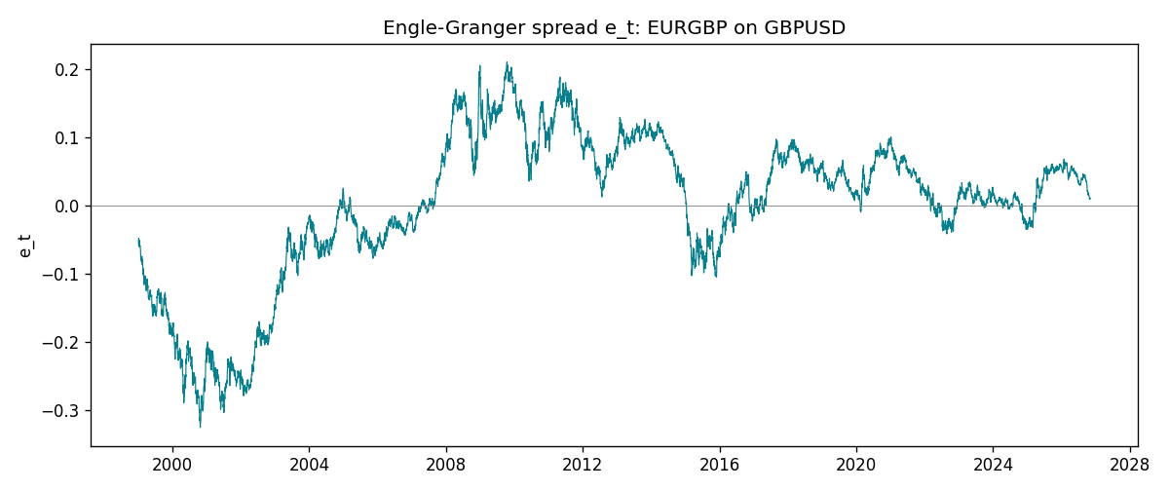
Daily log returns
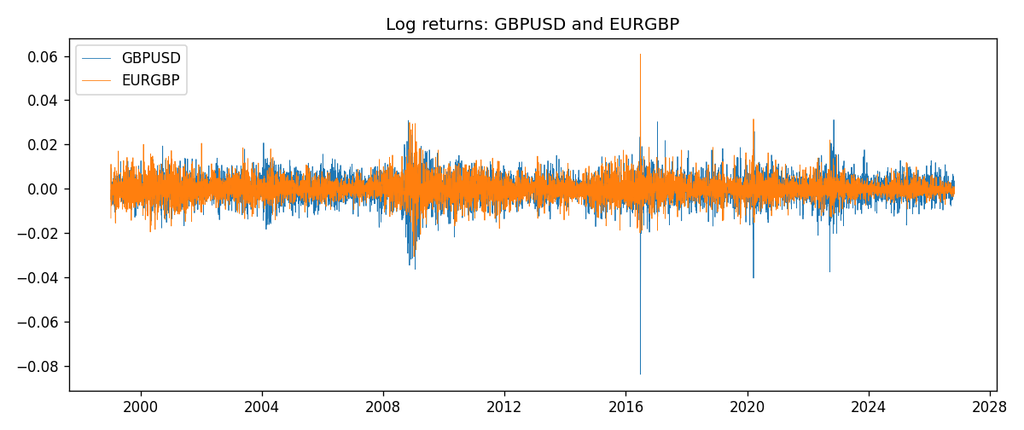

Data report
Matched rows are in the sibling Excel workbook named GBPUSD-EURGBP_Coint_D1.xlsx. Embedding all rows as a Word table is impractical; this file holds column summaries and the first and last 15 matched rows.
Column summaries
column | count | mean | std | min | 25% | 50% | 75% | max
GBPUSD_open | 7199 | 1.5160931 | 0.21831499 | 1.06854 | 1.324955 | 1.5114 | 1.63186 | 2.1066
EURGBP_open | 7199 | 0.78665041 | 0.09676322 | 0.5734 | 0.6873 | 0.83367 | 0.865175 | 0.9769
GBPUSD_high | 7199 | 1.5223838 | 0.21887686 | 1.08366 | 1.32978 | 1.5181 | 1.6384 | 2.1161
EURGBP_high | 7199 | 0.78972718 | 0.09713886 | 0.5789 | 0.68935 | 0.83657 | 0.86804 | 0.9799
GBPUSD_low | 7199 | 1.5097628 | 0.21753729 | 1.03518 | 1.3194 | 1.50323 | 1.62442 | 2.0983
EURGBP_low | 7199 | 0.78395066 | 0.09658082 | 0.5682 | 0.6853 | 0.83147 | 0.862765 | 0.9661
GBPUSD_close | 7199 | 1.5161471 | 0.21826306 | 1.06879 | 1.325055 | 1.51122 | 1.63216 | 2.1065
EURGBP_close | 7199 | 0.78669405 | 0.09676312 | 0.5735 | 0.6875 | 0.8337 | 0.86528 | 0.977
GBPUSD_tick_volume | 7199 | 94850.986 | 153561.38 | 62 | 9998.5 | 52911 | 91818.5 | 1273370
EURGBP_tick_volume | 7199 | 86949.029 | 145390.09 | 154 | 6517.5 | 44265 | 81326 | 1424684
GBPUSD_spread | 7199 | 26.96055 | 19.19062 | 0 | 11 | 20 | 50 | 50
EURGBP_spread | 7199 | 21.393666 | 19.14328 | 0 | 4 | 13 | 50 | 50
GBPUSD_real_volume | 7199 | 3.5570778e+09 | 8.4449923e+10 | 0 | 0 | 0 | 0 | 2.4038164e+12
EURGBP_real_volume | 7199 | 2.7805214e+10 | 1.3507095e+11 | 0 | 0 | 0 | 0 | 3.5726265e+12
GBPUSD_log_price | 7199 | 0.40612008 | 0.140885 | 0.06652717 | 0.28145397 | 0.41291727 | 0.48990429 | 0.7450278
EURGBP_log_price | 7199 | -0.24791231 | 0.12824902 | -0.55599734 | -0.37469345 | -0.18188165 | -0.14470213 | -0.02326863
GBPUSD_log_return | 7199 | -3.133e-05 | 0.00564236 | -0.08388241 | -0.00313644 | 2.978e-05 | 0.00317207 | 0.03112653
EURGBP_log_return | 7199 | 2.179e-05 | 0.00487166 | -0.03067367 | -0.0026225 | -0.00010035 | 0.00256076 | 0.06075387
spread_e | 7199 | -0 | 0.10764067 | -0.32493838 | -0.04617649 | 0.01788817 | 0.07073569 | 0.21024867
ecm_fitted | 7198 | 2.364e-05 | 0.00023122 | -0.00124389 | -0.0001179 | 2.083e-05 | 0.00016021 | 0.00269032
First 15 matched rows (selected columns)
time | GBPUSD_log_price | EURGBP_log_price | spread_e | GBPUSD_log_return | EURGBP_log_return
1999-01-06 | 0.5030152 | -0.35396434 | -0.058099314 | -0.00060452184 | -0.013303338
1999-01-07 | 0.50089649 | -0.34291293 | -0.048096446 | -0.002118709 | 0.011051402
1999-01-08 | 0.49500107 | -0.3478568 | -0.05595791 | -0.0058954193 | -0.004943862
1999-01-11 | 0.48931594 | -0.34913203 | -0.060046682 | -0.0056851331 | -0.0012752393
1999-01-12 | 0.49158164 | -0.345735 | -0.055528372 | 0.0022657001 | 0.0033970309
1999-01-13 | 0.50071468 | -0.34531119 | -0.050584676 | 0.0091330396 | 0.00042381861
1999-01-14 | 0.50265231 | -0.34729054 | -0.051605114 | 0.0019376331 | -0.0019793588
1999-01-15 | 0.50089649 | -0.35496213 | -0.060145639 | -0.0017558204 | -0.0076715819
1999-01-18 | 0.50210773 | -0.35424932 | -0.058833395 | 0.0012112405 | 0.00071280921
1999-01-19 | 0.50398226 | -0.35567544 | -0.059331831 | 0.0018745281 | -0.0014261269
1999-01-20 | 0.49907688 | -0.35367943 | -0.059763463 | -0.0049053846 | 0.0019960086
1999-01-21 | 0.50222878 | -0.35439184 | -0.058916013 | 0.0031518998 | -0.00071240297
1999-01-22 | 0.50470694 | -0.35610368 | -0.059401426 | 0.0024781662 | -0.0017118406
1999-01-25 | 0.50591358 | -0.36154392 | -0.064244513 | 0.0012066366 | -0.0054402425
1999-01-26 | 0.50663686 | -0.3621183 | -0.064460947 | 0.00072328374 | -0.00057438255
Last 15 matched rows (selected columns)
time | GBPUSD_log_price | EURGBP_log_price | spread_e | GBPUSD_log_return | EURGBP_log_return
2026-10-13 | 0.28166903 | -0.16891582 | 0.017406534 | 0.0036434319 | 0.00020130374
2026-10-14 | 0.27675256 | -0.16779163 | 0.016097596 | -0.0049164679 | 0.0011241873
2026-10-15 | 0.2833502 | -0.1686672 | 0.018487148 | 0.0065976411 | -0.00087557391
2026-10-16 | 0.28710941 | -0.17070529 | 0.018309468 | 0.0037592051 | -0.0020380844
2026-10-19 | 0.28535938 | -0.1712748 | 0.01687388 | -0.0017500314 | -0.00056950988
2026-10-20 | 0.29095172 | -0.17486542 | 0.016050867 | 0.0055923442 | -0.0035906254
2026-10-21 | 0.29219935 | -0.17627189 | 0.015261841 | 0.0012476328 | -0.00140647
2026-10-22 | 0.29242331 | -0.17814629 | 0.013498286 | 0.00022396082 | -0.0018743924
2026-10-23 | 0.29030862 | -0.17732208 | 0.013275948 | -0.0021146949 | 0.00082421033
2026-10-26 | 0.28787455 | -0.17719074 | 0.012202679 | -0.0024340661 | 0.00013133309
2026-10-27 | 0.28550971 | -0.17918648 | 0.0090366023 | -0.0023648393 | -0.0019957343
2026-10-28 | 0.2870869 | -0.1785168 | 0.01048681 | 0.0015771808 | 0.00066967224
2026-10-29 | 0.29067509 | -0.17968902 | 0.011090361 | 0.0035881935 | -0.0011722209
2026-10-30 | 0.29202015 | -0.18210958 | 0.009335468 | 0.0013450605 | -0.0024205543
2026-11-02 | 0.29311727 | -0.18121017 | 0.010777832 | 0.0010971256 | 0.00089940465

